**Experiment no.4 Achyuta.M**

**125010005**

**Mixing of ideal liquid streams**

**Objective**

Develop a simple process sheet to mix two liquid streams and estimate the flow rate and

composition of outlet stream.

**Data**

Inlet stream 1: 10 mol % Methanol solution flowing at 20 kmol/hr

Inlet stream 2: 80 mol % Methanol solution flowing at 10 kmol/hr

Both the streams are at 300C and at 1 bar pressure

The liquid streams can be considered as ideal

**Aspen Blocks Used**

Mixer

**Main Flowsheet**

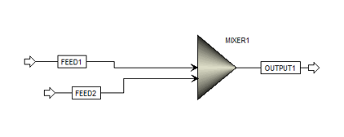

**Results**

|  |  |  |  |  |
| --- | --- | --- | --- | --- |
|  |  |  |  |  |
| Units |  | FEED1 | FEED2 | OUTPUT1 |
|  | Phase | Liquid Phase | Liquid Phase | Liquid Phase |
| C | Temperature | 30 | 20 | 26.4665119939 |
| bar | Pressure | 1 | 1 | 1 |
|  | Molar Vapor Fraction | 0 | 0 | 0 |
|  | Molar Liquid Fraction | 1 | 1 | 1 |
|  | Molar Solid Fraction | 0 | 0 | 0 |
|  | Mass Vapor Fraction | 0 | 0 | 0 |
|  | Mass Liquid Fraction | 1 | 1 | 1 |
|  | Mass Solid Fraction | 0 | 0 | 0 |
| cal/mol | Molar Enthalpy | -67039.1725790249 | -61568.5036524305 | -65215.6162701596 |
| cal/gm | Mass Enthalpy | -3452.4298618179 | -2329.3690465688 | -2997.6223455712 |
| cal/mol-K | Molar Entropy | -39.8617390183 | -49.0029790086 | -42.6340321285 |
| cal/gm-K | Mass Entropy | -2.0528275162 | -1.8539677874 | -1.9596644899 |
| mol/cc | Molar Density | 0.0487165169 | 0.0317397926 | 0.0412068491 |
| gm/cc | Mass Density | 0.945975767 | 0.8389274068 | 0.8964871977 |
| cal/sec | Enthalpy Flow | -372439.84766125 | -171023.621256752 | -543463.468917999 |

**Verification**

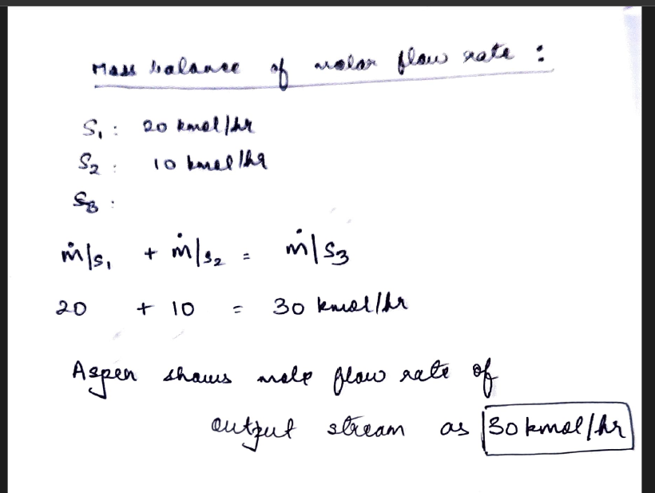

**Specific learning**

Aspen allowed me to simulate a mixer operation and understand the relation between change in parameters and results obtained. Aspen is highly accurate and helps in designing process simulation for industries.